January 18, 2019

Professor Meg Daly
Chair, Arts and Sciences Curriculum Committee

Re: Approval of Revision for BA in Theatre

Dear Meg,

The Arts & Humanities Panel 1 of the ASCC approved a proposed revision from the Department of Theatre. The BA revision was approved by our panel on February 5, 2019.
The BA revision is based on conversations with students and faculty, benchmarking peer institutions and best practices to craft a targeted revision that allows flexibility, program efficiency, and aims to promote improvements in student learning outcomes. In brief, the BA revision involves adjusting required courses in two areas to include existing or newly added courses, therefore expanding the course options for one of the requirements. In addition, they added a new Experiential Learning requirement that includes existing courses as options, all without increasing the total required credit hours. The proposal also attends to a transition plan, so that students understand program changes.
The panel agreed that the proposed BA revision, as articulated, offers better options for students. The revision was unanimously approved with no contingencies by our committee. We now advance the proposal to the Arts and Sciences Curriculum Committee with a motion to approve.

Best,
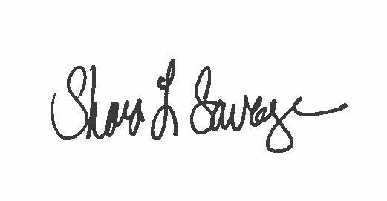

Shari L. Savage, PhD
Associate Professor
Undergraduate Education, Teaching & Assessment Chair
savage.12@osu.edu

